CS 590BD

LAB – 2 Report

Submitted by Saikiran Pasala (16154892)

Task 1: Collecting data fro Sensors and Android mobile device

* Used the BLE sensor and Android deviceand collected data. The text file generated is copied from the android device to the computer.
* Imported the app1-app3 from blackboard into the eclipse and make necessary changes. Run the application Collect data from the sensor.

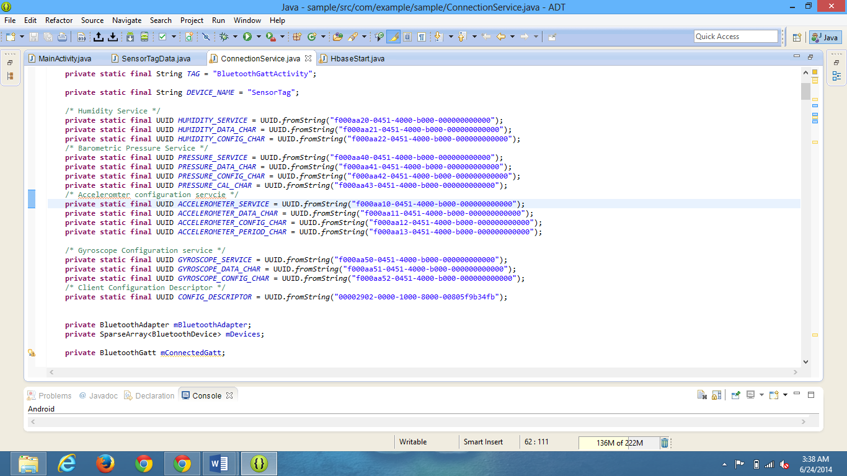

Task 2: Pushing data to the hbase

* Created a Htable in habse using the hbase client project given to us.

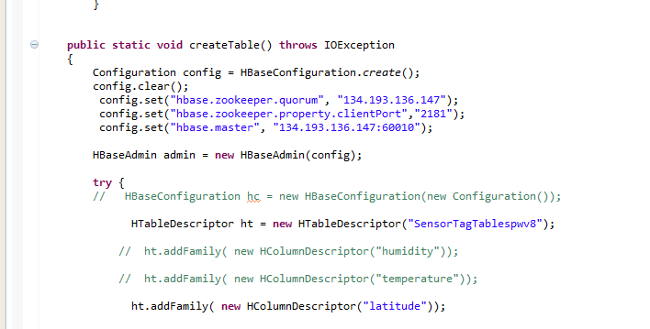

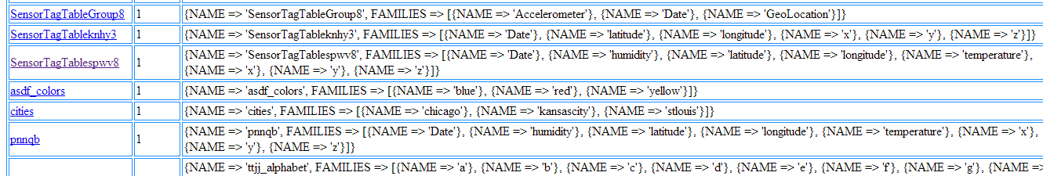

* Inserted the data that is collected into the hbase making necessaray changes to the hbasestart.java

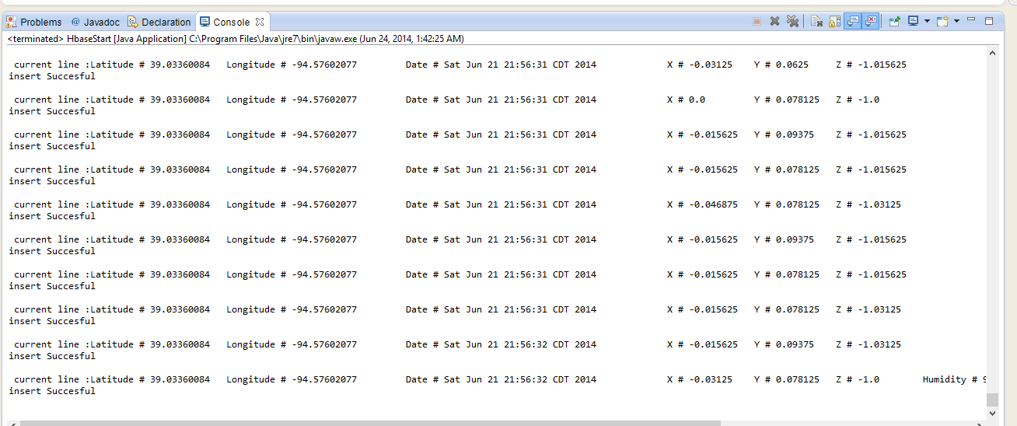

* After Inserting the data into the hbase now wrieve the data using the retrievetable method

